How to support your child at home with learning sight words

Being able to instantly recognise words in texts supports the development of automaticity of basic sights words for different texts they read. The table below outlines the key sight words that we recommend children learn at each

Reading colour level. Click on the links in the table below to access level appropriate list words. You might like to print and enlarge and cut up the words to use as a support for learning.

Reading Levels | Sight Word Lists to Support Reading
Magenta Level  Towards Early Level 1 | Magenta sight words
Red Level  Towards Early Level 1 | Red sight words
Yellow Level  Towards Early Level 1 | Yellow sight words
Blue Level  Early Level 1 | Blue sight words
Green  Early Level 1 | Green sight words
Orange  At Level 1 | Orange sight words
Turquoise  At Level 1 | Turquoise sight words
Purple  At Level 1 | Purple sight words

Year 0-2
- Print the relevant word list and cut them up and use these words as flashcards.
- Set goals with your child. How many can they get right? Raise the goal by just a few words each time to build in success. Use a reward chart to motivate your child.
- Practice in short sessions. 2 short sessions (5-8mins) will be more productive than a long session.
- Work with 6 or 7 new words at a time. Print 2 sets of the flash cards for these words and play
  - memory
  - snap
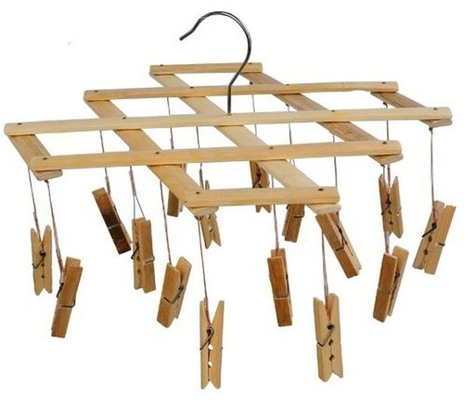
  - go fish
- Use magnetic letters to make the words on the fridge.
- Make a mobile with pegs with your child. Peg up the words your child is learning and as your child masters a word take it off and add a new word.

- Display flashcards on the fridge or on a wall in your child’s bedroom. Turn down the light and give your child a flashlight. Have your child shine the light on the words and read each word.
- Write the words - white board, pencil/colour pencils/highlighters and paper, or chalk on the concrete outside.
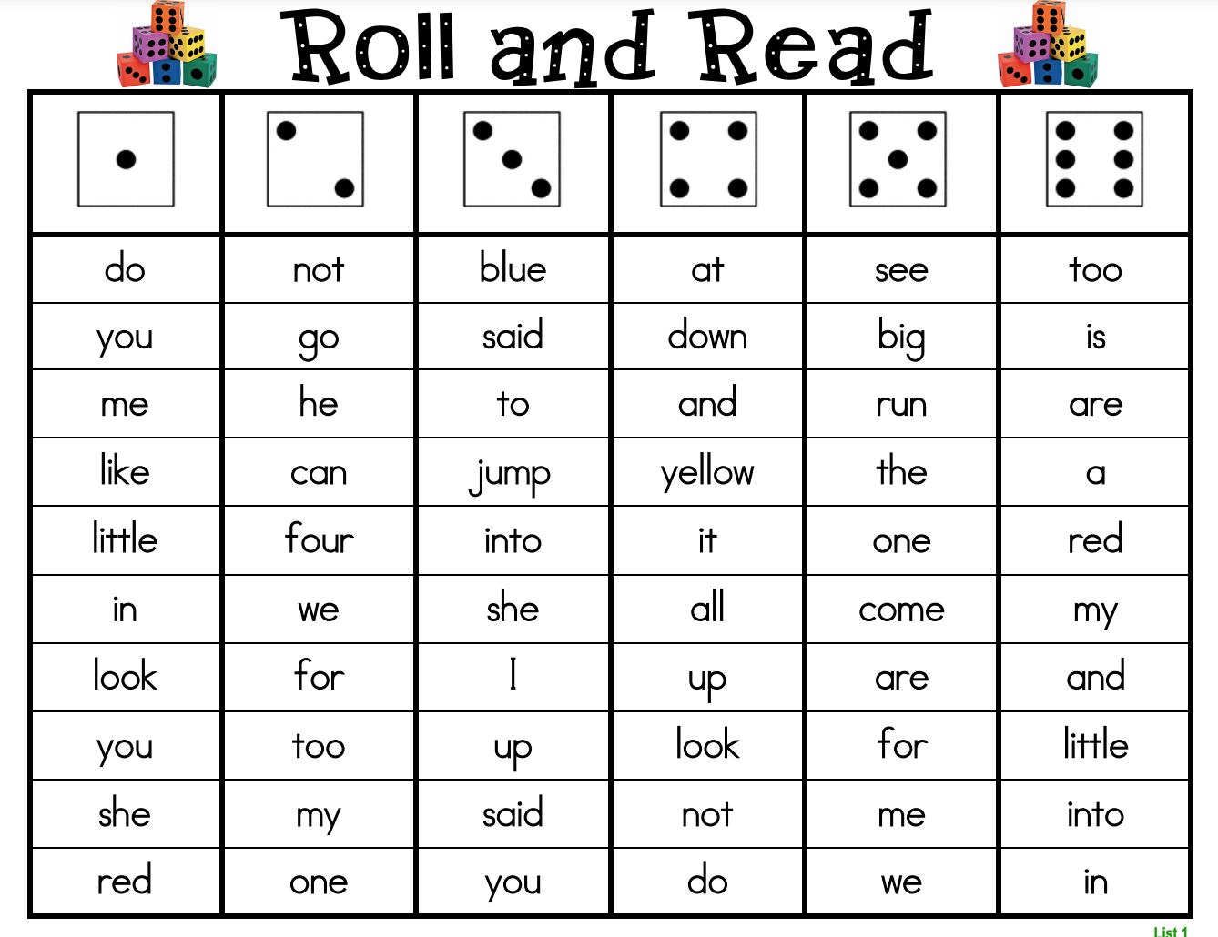
- To revise learnt words, make a game board as follows. Take turns to roll the dice. In the column that matches the number rolled, read and circle the word you have read. The first person to circle all the words in a column is the winner.

Year 3-4
- Print the relevant word list and cut them up and use these words as flashcards.
- Set goals with your child. How many can they get right? Raise the goal by just a few words each time to build in success. Use a reward chart to motivate your child.
- Practice in short sessions. 2 short sessions (5-8mins) will be more productive than a long session.
- Work with 6 or 7 new words at a time. Print 2 sets of the flash cards for these words and play
  - memory
  - snap
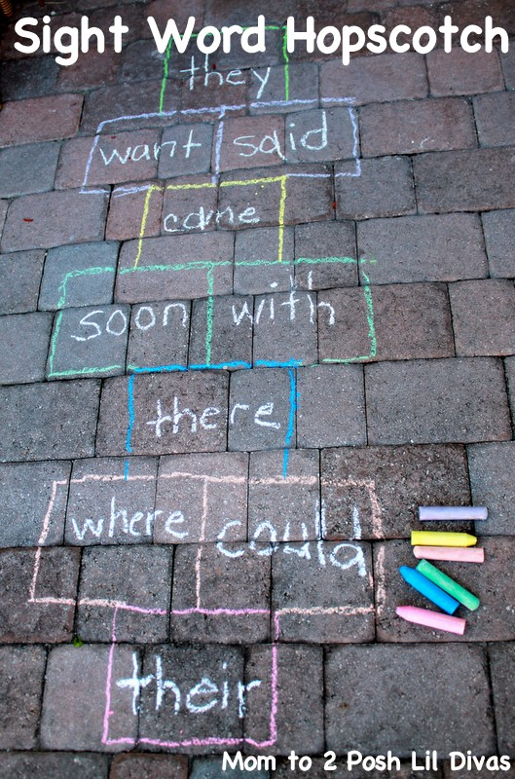
  - go fish
- Create a sight word slideshow presentation.
- Cut out letters from a magazine to make each sight word.
- Create a sight word book, use this book to revise known sight words and to add in new sight words.
- Breakfast challenge - place the sight words on the fridge, read the words as fast as you can before eating breakfast.
- Play sight word hunt- hide cut out sight words around the house, go on a sight word hunt.
- Create a sight word wordsearch.
- Play sight word hopscotch. Draw a hopscotch outline with sight words in each box. Throw a token onto a sight word, spell the word aloud before jumping to retrieve the token.

